PowerShell Script that configures your PowerShell Environment.
------------------------------------------------------------------------------------------------------------------------------------------
Part 1:
In this part of the script you will create a warning message to be displayed on your local host computer whenever a user opens powershell. (Reference page 57-59 of your textbook)
- Create a script call Microsoft.PowerShell_profile.ps1
  - NOTE: The script will need to be saved into the C:\Windows\system32\WindowsPowerShell\v1.0 folder on the computer you want the profile to apply to.
- Enter the Following into your script
# PART 1
# create an object variable, by using the Get-Host cmdlet and its UI property to access the RawUI property, which can be used to access and configure console properties.
$PSConsoleWindow = (Get-Host).UI.RawUI

#set the background and foreground color, and change PS console window title
$PSConsoleWindow.BackgroundColor = “Yellow”
$PSConsoleWindow.ForegroundColor = “Red”
$PSConsoleWindow.WindowTitle = “(your name)’s Customized PowerShell Console Session”

# create an object reference variable , by using the WindowSize property, which can be used to set the windowsize properties width and height.
$PSConsoleSize = $PSConsoleWindow.WindowSize

$PSConsoleSize.Width = 80
$PSConsolesize.Height = 25
#reassign the $PSConsoleSize settings to the the $PSConsoleWindow objects WIndowSize property.
$PSConsoleWIndow.WindowSize = $PSConsoleSize
Clear-host

- save your script, close any open PowerShell windows, and then open a new instance of PowerShell to verify:
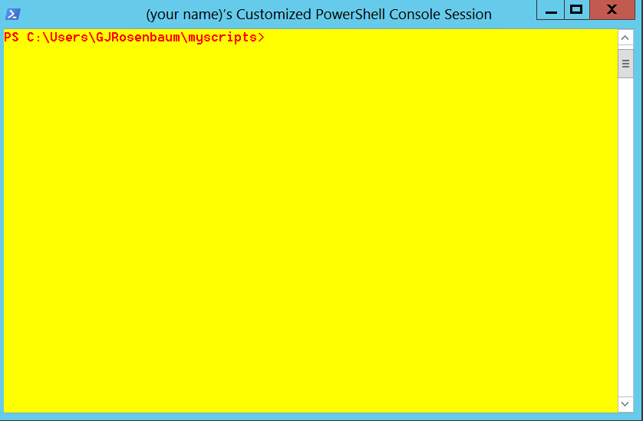

--------------------------------------------------------------------------------------------------------------------------------------
Part 2:

In this part of the script you will add a warning message to be displayed on your local host computer whenever a user opens PowerShell. (Reference page 92-94 of your textbook)
- Modify your script called Microsoft.PowerShell_profile.ps1 . Append the following text into your profile script:
#part 2
#create an alias for the Write-Host command
Set-Alias ds Write-Host

#clear the console screen
Clear-Host

#Display Warning message
ds
ds “--------------------------------------------------------------------------------“
ds “This computer and network are private.”
ds “Unauthorized access is prohibited!”
ds “For authorization contact your name at 406-555-1234”
ds

#prompt user acknowledgment of warning message:
ds “By pressing ENTER, you acknowledge that you are authorized“
ds “to use PowerShell on this computer: ‘$env:COMPUTERNAME’ “
ds “and agree to the security policy”
ds “--------------------------------------------------------------------------------“
Read-Host “press enter”

#reset background and text colors
$PSConsoleWindow.BackgroundColor = “Black”
$PSConsoleWindow.ForegroundColor = “White”
Clear-Host

3. save you script, close any open PowerShell windows, and then open a new instance of PowerShell to verify your message displays
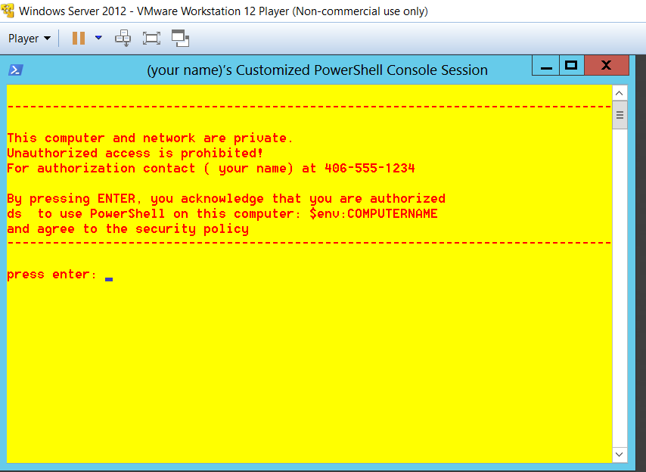
After pressing enter:
